THE ENTERPRISE SHARED USE KITCHEN 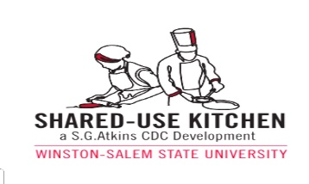
CHECKLIST TO BECOMING USER/ TENANT:

1. Submit complete Application
2. Schedule interview with Kitchen Coordinator
3. Present (COI) Certificate of Liability Insurance and current ServSafe certification
4. Submit Food Service Permit Application for NC Health Department (Timeframe varies for permit)
5. Sign kitchen user/tenant contract and package selection
6. Accept and sign ‘Standard Operating Procedures Handbook’
7. Schedule kitchen orientation and pay fees with certified check or money order to S.G. Atkins Community Development Corporation
8. Schedule kitchen hours with Coordinator, receive invite to online scheduling tool and assigned key (schedule maximum 3 months in advance online).

Any questions, contact Kitchen Coordinator, Telissa Fair Ward at 336.464.3140 or email sgatkinscdc7@gmail.com

